Shobnall Primary School
Newsletter

Telephone: 01283 239100 Twitter: @shobnallprimary e-mail: headteacher@shobnall.staffs.sch.uk
Friday 25th November
Dear Parents,
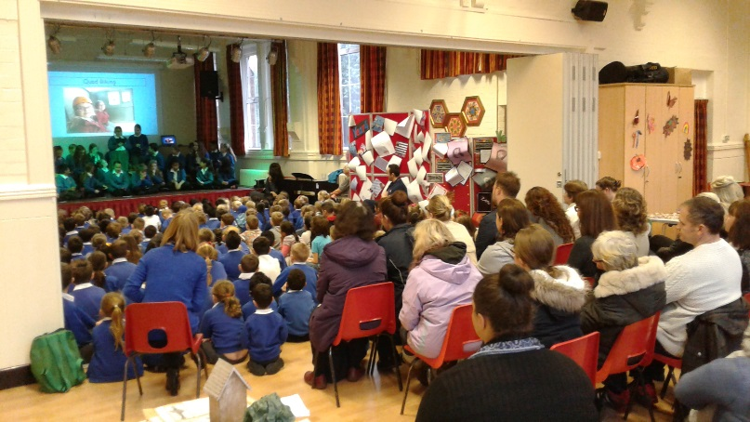
It was great to welcome so many of our Year 6 parents into school this week for the class assembly. We were delighted that so many parents and grand-parents arranged time off work to come in and have a look at the World War 2 projects as well as listen to the Year 6 children tell us all about their adventures at Kingswood. This was the first class assembly of the year and the adults all seemed to enjoy the refreshments on offer as well as taking the opportunity of looking at some of the work the children have been completing. We are now looking forward to the Year 5 class assembly which will be on Wednesday 11th January and I would like to take this opportunity of inviting all Year 5 parents and grand-parents to this event which will be starting at 9.00am.
Year 3 and 4 Swimming Gala
Year 3 and 4 took the Dove Valley Swimming tournament by storm on Monday winning a Silver medal in the team event competing against 7 other schools! The team consisted of Ceron. G. Robey. W, Francesca. E., Olivia. R., Amber. W., Daisy. T. and Patrick. B. Francesca. E. in Year 3 did especially well winning 1st place in Front Crawl and Back Stroke! Robey W also got 1st place in the Back Stroke event! Amazing effort from all of the Year 3 and 4 swimming team! Mr Attwood would like to thank the parents for their continued support.
Punctuality Reminder
Sadly, I will have to enter a little moan in this week’s newsletter regarding the steady drop in punctuality at the start of the school day. The school gates open at 8.30am and the bell will go at 8.45am for pre-school learning prior to the register being taken at 8.55am. A significant number of children and parents are arriving at 9.00am or even later and this is becoming a trend unfortunately. Please can I encourage you all to teach the children the importance of punctuality and time-keeping and ensure that they are in the classroom no later than 8.55am. Many children are in class at 8.45am and these pupils are benefitting from a total of roughly an hour extra learning each week due to their promptness. This will ensure that some children will benefit from nearly 36 hours of extra learning a year in comparison to their peers who arrive late! That is some figure and please consider this when planning your morning routine.
PFA Christmas Fair
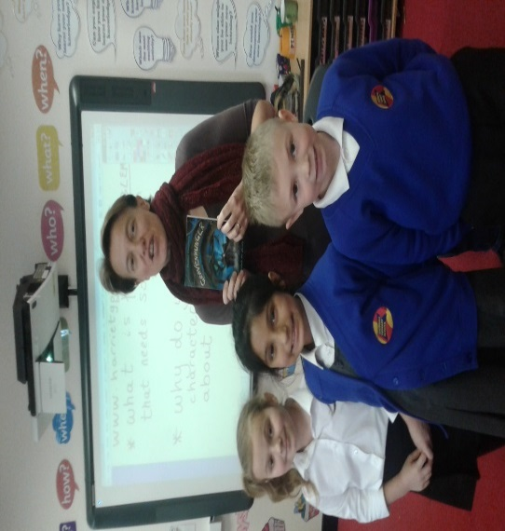
Can I remind you that the Christmas Fair is almost upon us and that this time next week we hope to welcome you all into school from 3.30pm onwards. The choir will be singing and plenty of fun activities, refreshments and entertainment will be on offer. I really hope that as many of you as possible will be able to come along and support the PFA in their fund-raising towards redesigning and reorganising of the Key Stage 2 library. Raffle tickets are on sale each and every morning as well as booking your slots for seeing Father Christmas if you so wish. Please can I take this opportunity to encourage you to buy raffle tickets as the list of prizes is fabulous. Some of the prizes include: Over night stay for 2 at the Riverside Hotel, Spa day for 2 at Branston, Spa day for 2 at St. Georges, Match tickets for the Brewers, Meal vouchers for various restaurants, Family day passes plus many more.
Key Stage 2 author visit
We were lucky this week to have finally met Harriet Goodwin, author of The Boy Who Fell Down Exit 43 and The Hex Factor. The children were captivated as she explained where she finds inspiration for her stories and how she engages with the writing process. She also entertained us with some opera singing! Year 3 and 4 also took part in a creative writing workshop, led by Harriet herself and produced some great work! If any children would like to order any of her books and have them signed, please complete the order form previously sent out and return to the office by Tuesday 29th November.

Nursery class activities
Nursery class this week have been involved in lots of exciting activities to enable the children to learn more about the festival of Diwali. The children have listened to the story of Rama and Sita and have understood that Hindus celebrate how this story recognises that good always triumphs over evil. The children have made Rama and Sita puppets, designed Mendhi handprints and finally made their own Diwa lamps.

Orangutan Success
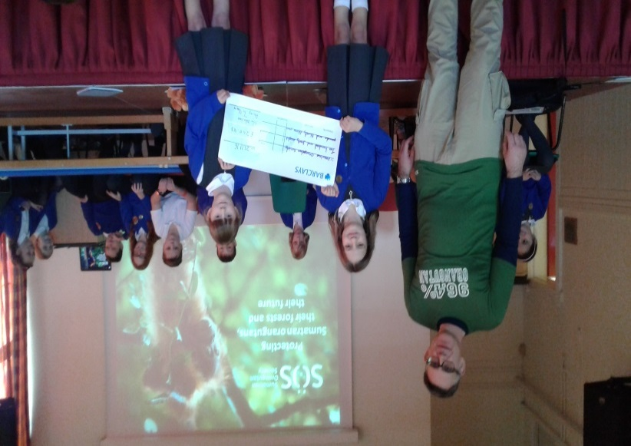
The children welcomed in a member of the “Save the Orangutan” society this morning in assembly. It was an opportunity for the children to learn and understand more about how the money, that they all helped raise, was going to help the plight of the Sumatran Orangutan. Once again, we celebrated the achievements and enterprise of both Isla and Daisy in Year 4 who were responsible for organising the cake sale a few weeks ago and it was wonderful to learn that the £250 raised will have such a positive impact on the Orangutans and their local environment.

Head Teacher Assembly Awards
Reception | Ibraheem M. | Eva W.
Year 1 | Charlie J. | Anaya A.
Year 2 | Lucy T. | Skye W.
Year 3 | Areesha F. | Sayaan U.H.
Year 4 | Daisy T. | Isla J
Year 5 | Safiya N. | Damian E.
Year 6 | Natalia E. | James W.

Lunchtime Star Awards
Reception | Sophia R.
Year 1 | Finley D.
Year 2 | Isabelle L.
Year 3 | Grace W.
Year 4 | Brielle P.
Year 5 | Grace C.
Year 6 | Heather B.

Autumn Term 2016 – Dates for your diary
Event | Date and Time
Year 3 Production at School | Friday 2nd December 2016 9.15am for a 9.30am start Main Hall
Christmas Fair | Friday 2nd December 2016 3.30pm – 6pm
Key Stage 1 Christmas Performance Year 1 & 2 | Mon 5 & Wed 7 December 9.15am for a 9.30am start
Key Stage 2 Performance at the Brewhouse | Tues 6th December 2016 1.30 pm and 6.00 pm
Foundation Stage Nativity Main Hall | Thursday 8th Dec and Friday 9th Dec 9.15am for a 9.30am start
Christingle Service St Aidan’s Children Only | Monday 12th December 2016
Influenza Vaccinations for Years 1, 2 and 3 | Medical Room Tuesday 13th December 2016
Visit to Derby Playhouse for Pantomime | Wednesday 14th December 2016
Christmas Lunch for all Pupils | Thursday 15th December 2016
School Closes for Christmas Holiday | Friday 16th December 2016 at 3.30 pm
School re-opens for the Spring Term | Wednesday 4th January 2017
Year 5 Class Assembly | Wednesday 11th January 2017 at 9.00am

