Shobnall Primary School
Newsletter

Telephone: 01283 239100 Twitter: @shobnallprimary e-mail: headteacher@shobnall.staffs.sch.uk

Dear Parents, 16.12.16
It has been a wonderful end to the term this week and the children have certainly enjoyed the celebrations and festivities. All staff have been able to focus a little more on some of those subjects which had unfortunately taken a back seat during the preparations and rehearsals for our performances and it was noticeable that many of the children actually responded positively to a return to the routines, especially at the beginning of the week. I would also like to take the opportunity to say a huge thank you on behalf of myself and the office staff, for all the cards and gifts that we received. We have been overwhelmed with your generosity and kindness! On the downside, we may all return from the Christmas break a little rounder and heavier than we were prior to Christmas!
I would also like to pass on my Christmas wishes to you all and hope that you have a relaxing and peaceful break, whether you are celebrating Christmas or if you are just planning to enjoy putting your feet up for a few days over the holiday. It is a fabulous time of the year and I hope you have a fantastic time celebrating (and/or relaxing) and I therefore wish all of our school family a Happy Christmas and a prosperous 2017. Don’t forget that we return to school on Wednesday 4th January at 8.45am and pre-school sessions for the children who attend, will begin again on Monday 9th January 2017 at 8.30 am.
Christingle Assembly
The final week began with a whole school visit to St. Aidan’s Church to celebrate our Christingle Assembly with Father Stanley Monkhouse. I must say, this assembly actually displayed the best behaviour and singing that I have ever heard Shobnall children perform at the Church. The theme focussed around the Christingle and the history behind it and I could not believe the number of pupils who actually made one! I have never seen so many Christingles, thank you to all parents and family members who spent time with their children making them. One final observation I made was that this year was the first time that every single child in school attended the church. I was so pleased that all of our children came together to show respect for the festival of Christmas. I am incredibly proud and grateful to all of our families who have helped to promote the true meaning of a school family and community.
The School Website
I am aware that a number of parents have been trying to access the school website recently for various reasons but unfortunately the site has suffered from a virus which has resulted in it being taken off-line. However, please can I inform you that we are currently working on rebuilding a brand new website which is now being designed for easy navigation and simple links. Of course, there will also be a Twitter link on the home page which will replace the “Latest News” section and you will all be able to access this I believe, whether you are registered on Twitter or not. I will be writing to you early in the New Year with news of our new launch for the website so please watch this space.

Alice in Wonderland in Derby
The whole school packed up their belongings on Wednesday lunchtime to visit Derby for a fabulous performance of “Alice in Wonderland”. It was a great way to bring the term to a close and the children certainly deserved to be the ones being entertained for a change, especially after such fantastic Nativity and Snow White performances last week. We all thoroughly enjoyed the trip (even though some of us returned slightly later than planned) and it was great to see our Reception children with mouths wide open throughout! A huge thank you must also go to those volunteers who kindly gave their time to support our children during the afternoon.
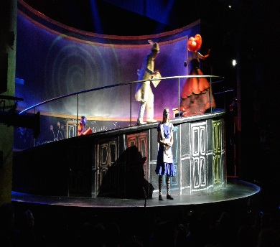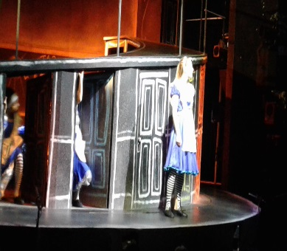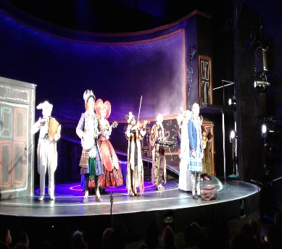
Christmas Dinner
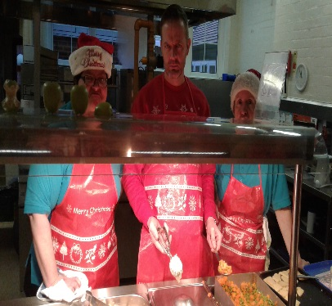
Once again our kitchen staff managed to serve up an absolute treat to the vast majority of the children and staff this week. It always amazes me how they manage to cater for such huge numbers, especially as there are only 3 of them! The children thoroughly enjoyed the lunchtime celebrations with the crackers and party hats plus Christmas music to set the theme. Thank you to Mrs Inger, Mrs Whetton and Mrs Lambert for such a lovely dinner yesterday! In addition to this, we had a very special visitor before our lunch and I am surprised you didn’t hear the scream from the Key Stage 1 playground as Santa and his sleigh pulled in to the school gates!!!!
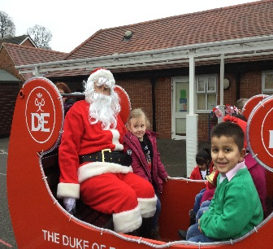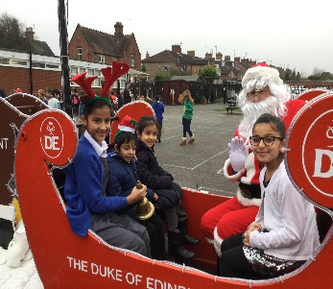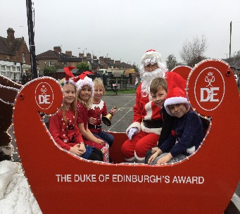
Governors of Shobnall School
This term has seen considerable changes to the Governing Body and I would like to update all of our school community with these changes as our Governors do play a very active and healthy role in the running of the school. Mrs Taylor has decided to step down from role of Chair of the Governing Body but will remain as a Governor. Mrs Melanie Dixon has been voted in to the position of Chair as a result of this and Mr Gary Dennis is now our Vice Chair. We, of course, welcome Mrs Ruth Urquhart and Mrs Becky Tyler onto the Governing Body and both come with huge knowledge and experience of Education and in Mrs Tyler’s case, she currently works for the local authority within the Special Educational Needs section and therefore she will be able to support the school further in this aspect. Of course, Mr Andrew Redfern and Mr Phil McComish are our new parent governors and we are delighted that Mrs Julie Brewer and Mr Dave North remain with our team. And finally, Mr Adams is now our new staff Governor Representative and I would like to say a huge thank you to Mrs Waldron, who has stepped down from this position, for all her hard work and dedication that she offered to this role during her time as staff governor representative.

Year 5 Visit to the Galleries of Justice, Nottingham
Year 5 enjoyed a superb day out to the Galleries of Justice in Nottingham. This is Nottingham’s old Courthouse and jail, and the children had the opportunity to experience being locked up. The legend of Robin Hood has a particular importance and connection to the Galleries of Justice Museum, as for centuries, this historic building was the base of the Sheriff of Nottingham!
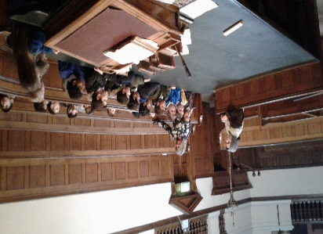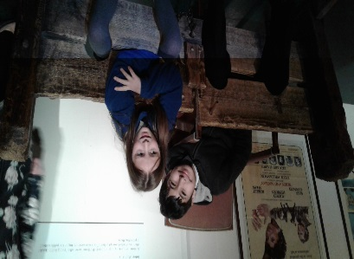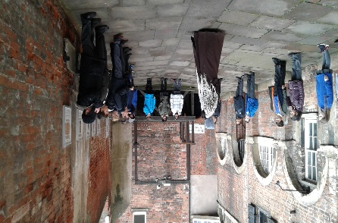

Vacancy for Kitchen Assistant
From January 2017 we require a catering assistant to join our team in the kitchen. The hours are 15 core hours per week. The duties will be varied, including food preparation, serving the children, pot washing general kitchen duties including cleaning.
If you are interested please speak with Mrs Inger for further details prior to a formal application being made. Thank you.
Head Teacher Assembly Awards
Due to it being the final week of term and the fact that the majority of this week has taken place outside of the classroom, the school has not selected pupils this week for the Head Teacher Awards but will be returning to these in January.
Lunchtime Star Awards
Reception | Leah W.
Year 1 | Charlie J.
Year 2 | Elsie W.
Year 3 | Ayaan M.
Year 4 | Alannah S.
Year 5 | George W.
Year 6 | Trinity S.
Spring Term 2017 – Dates for your diary
Event | Date and Time
Tuesday 3rd January 2017 | Inset Day School Closed to Pupils and Staff
School re-opens for the Spring Term | Wednesday 4th January 2017
School Meal Service Change of Menu Sausage & Mash (Including vegetarian option, jacket & beans, cheese/egg pack lunch. | Wednesday 4th January 2017
Year 5 Class Assembly | Wednesday 11th January 2017 at 9.00am
PFA Meeting | Wednesday 18th January 3.30pm
Young Voices concert – NEC, Birmingham | Monday 30th January – leaving around 12.15pm – 9.00pm

HAPPY HOLIDAYS TO ALL OF OUR CHILDREN, PARENTS, FRIENDS AND STAFF AND MAY WE WISH YOU A VERY HAPPY AND PROSPEROUS NEW YEAR

