Shobnall Primary School
Newsletter

Telephone: 01283 239100 Twitter: @shobnallprimary e-mail: headteacher@shobnall.staffs.sch.uk

Dear Parents, 2nd December 2016
The Christmas preparations are now well and truly underway and the school remains very busy in ensuring that the Nativity and Pantomime performances are perfected and ready to put on a show to all parents and the wider community. In fact, this morning, the Year 3 class opened up the proceedings with their wonderful acting and singing to a packed hall. Miss Kirkland and her class have managed to set the bar very high indeed for the quality of the performance and a huge thank you to all involved, it was a real treat to be in the hall today.
The rest of the school remain incredibly busy with their final touches for the plays next week, from the EYFS through to Year 6. Both sides of the hall have been filled with wonderful sounds of singing, acting and dancing to prepare for the big days next week and I very much look forward to welcoming as many of you as possible into school.
On my travels around the school this week, I have loved observing the varied and exciting learning which our teachers are creating for the children. It amazes me how some of our Early Years staff continue to provide a quality education in the outdoor classroom, even working at temperatures below zero! Miss Walton now possesses a new hat and gloves and it was certainly needed this week as she was leading counting activities outside on Monday! I can imagine she needed to thaw out after her morning session. Inside the Early Years classroom, a visitor to the school commented on how impressed he was that two reception pupils could describe “different vertices” and identify the “corners and faces on a 3D shape.” Wow!
Year 1 children were learning the chronological order of the days of the week and some were using the netbooks and playing on interactive games to reinforce their learning and understanding of this concept. In addition, some of the children were really challenged by word problems, some being very complex, to understand days of the week.
Year 2 have been working very hard on co-ordinates this week and Mr Gordon created various activities to promote and support their learning. Pupils were enjoying working on the carpet and engrossed in working on a large scale grid with different objects being placed on different points for the children to locate.
Zig Zag line danger
It has been brought to my attention that a significant number of parents are beginning to drop their children off for school outside, on the zig zag lines, adjacent to the railings. Please can I strongly urge you to refrain from such practice due to the considerable dangers this behaviour poses. We do have Community Officers who do patrol the school drop off on occasion and they have notified the school that such an offence could be liable to prosecution. Please can I ask you to consider the dangers that this action poses to both your children and also to others whilst also being considerate
to other road users. May I also take this opportunity to ask that if you do see such actions, please make a note of the registration and the school will pass this on to the Police.

Years 3 and 4 Indoor Canoeing
Year 3 and 4 took part in an Indoor Canoeing competition at Robert Sutton High School on Tuesday. The children used state of the art indoor rowing machines and big screens were displayed in front of them to make them feel like they were actually rowing on a river. The children thoroughly enjoyed it and did particularly well winning a team Bronze medal award! Well done Zeb.S., Ceron.G., Areesha.F., Scarlett.S.,Aadam.A., Patryk.B, Freya.C., Laiba.K!
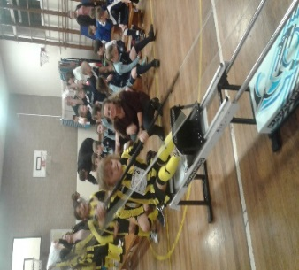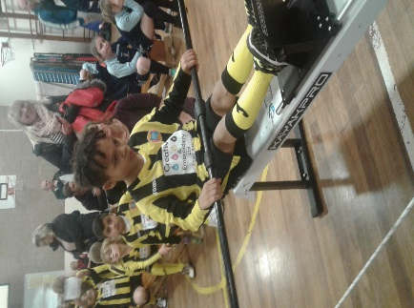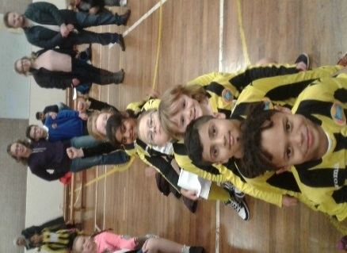
Years 4, 5 and 6 Brewhouse performance
Arrangements are now well in hand for our production of “Snow White and the Eight Dwarves”. The children have been rehearsing really intently and are ready to put on the show for you all to enjoy. Please check you have your Brewhouse Tickets ready for the performance on Tuesday 6th December 2016. We still have a few seats available for the evening and matinee performances. Please call the Office on 01283 239100 if you have any questions.
Year 3 Christmas Play – “The Innkeeper’s Breakfast”
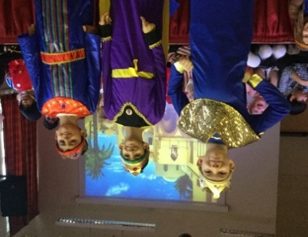
In keeping with the school’s desire to keep our parents up to date, we have of course “tweeted” a number of photos from this morning’s wonderful Nativity performance. Please remember to follow us @shobnallprimary to see more photos from this week’s learning and celebrations. I was delighted to see the Year 3 children on stage today, it certainly was an alternative take on the Nativity theme and to see Jack Frost, the Grinch and Santa all in the same story was wonderful. I also thought that Archie S. and his ‘beautiful’ wig suited him down to the ground, perhaps he may want to pop one of these on his letter to Father Christmas? A huge thank you to all parents who came along today and also to those who spent a great deal of time crafting the fabulous outfits. In addition, I must also say ‘thank you’ to all the charitable donations that parents kindly gave for the St. Giles Hospice, Whittington.
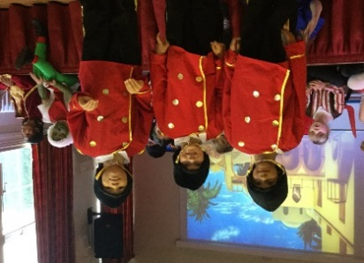
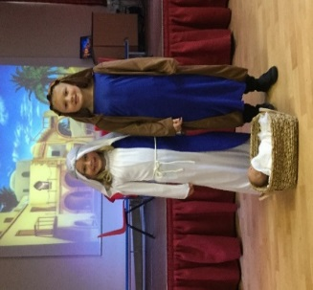
Shobnall Primary to become an Academy?
I am aware that a number of parents have raised this current political issue with a few members of school staff and governors. At this current time of writing, I want to ensure that all parents are fully aware of any possible decisions and direction that the school may be taking. You may be aware that in the media, there has been considerable mention of all schools being required to convert to become an Academy. This is not necessarily the case and the school Governing body is currently investigating and researching possible next steps with regards to this matter. A number of the school staff and governors attended the Academy Show at the NEC last week to begin fact-finding and what converting would mean to Shobnall Primary School and its children. That is currently as much as I can report and further plans will be discussed at the full Governing Body meeting later this month. I can confirm that all parents will be consulted in due course as to whether it is in the interests of the school to convert or not. Please watch this space.
Head Teacher Assembly Awards
Reception | Amira H | Keeva D
Year 1 | Cruz AS | Maja I
Year 2 | Haniya N | Jack M
Year 3 | The whole class for their superb Christmas Production – Well Done!
Year 4 | Ihsaak M | Ihsaan N
Year 5 | Ava R | Fin M
Year 6 | William W | Jay HC
Lunchtime Star Awards
Reception | Lucy W | 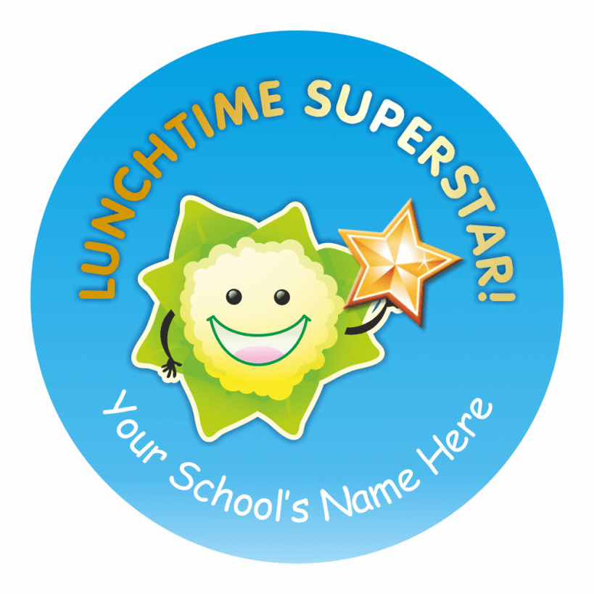
Year 1 | Cruz AS
Year 2 | Sienna S
Year 3 | Dylan P
Year 4 | Rhys L
Year 5 | Spencer W
Year 6 | Charli G
Autumn Term 2016 – Dates for your diary
Event | Date and Time
Christmas Fair | Friday 2nd December 2016 3.30pm – 6pm
Key Stage 1 Christmas Performance Year 1 & 2 | Mon 5 & Wed 7 December 9.15am for a 9.30am start
Key Stage 2 Dress Rehearsal at the Brewhouse | Coach will leave school at 9.00 am and the children will return to school at 1.45 pm.
Key Stage 2 Performance at the Brewhouse | Tues 6th December 2016 1.30 pm and 6.00 pm
Foundation Stage Nativity Main Hall | Thursday 8th Dec and Friday 9th Dec 9.15am for a 9.30am start
Year 2 Super Hero non-uniform day. | Friday 9th December. 1-2.30pm Parents invited to class to help their child make a super hero costume
Christingle Service St Aidan’s Children Only | Monday 12th December 2016
Influenza Vaccinations for Years 1, 2 and 3 | Medical Room Tuesday 13th December 2016
Visit to Derby Playhouse for Pantomime | Wednesday 14th December 2016
Christmas Lunch for all Pupils  “Christmas Jumper” non-uniform day | Thursday 15th December 2016
School Closes for Christmas Holiday | Friday 16th December 2016 at 3.30 pm
School re-opens for the Spring Term | Wednesday 4th January 2017
Year 5 Class Assembly | Wednesday 11th January 2017 at 9.00am

