Shobnall Primary School
Newsletter

Telephone: 01283 239100 Twitter: @shobnallprimary e-mail: headteacher@shobnall.staffs.sch.uk

Dear Parents, 9th December 2016
The school has been celebrating the build up to Christmas this week through a series of Nativity plays and a huge production, as always, at the Brewhouse Arts Centre in town. It has been an incredible week and seeing the faces of the children performing has been a real treat. The look of delight on our Early Years children as they spot parents and grandparents is always a treat and this year was no different. As you can imagine, the whole school can now breathe a sigh of relief as the fabulous celebrations are finally over and we can all look forward to now being the ones ‘entertained’ when we visit Derby Theatre next week for our Pantomime trip to see Alice in Wonderland. Can I also take this opportunity to remind parents that the school is now on Twitter and we are all certainly very active ‘tweeters’. If you have not joined the 136 other followers that the school now proudly boasts, you are not aware of a huge amount of fun and fabulous information being shared on this. This week has certainly been one of our busiest weeks since joining Twitter and if you are still unsure, speak to parents who have joined, of which there are plenty, they will enlighten you further I’m sure as to the materials on here and why you should all join!!!! Highlights this week on Twitter include photos of all of our performances, netball and a letter from the Queen’s Lady in Waiting!
Can I also take the opportunity of thanking all parents who not only attended and supported the children at the various performances throughout the week but also to the kindness and generosity that you have displayed in your donations. This year, the school has chosen to support St. Giles Hospice in Whittington, who work tirelessly to offer specialist care in a variety of settings for patients with cancer and other serious illnesses, as well as providing support for their families and helpers. Many of us sadly know someone who has suffered from Cancer and I have recently witnessed first-hand the amazing work that St. Giles offers to both patients but also the families. Therefore, as a school we are proud to forward on your heart-felt donations to such a fabulous and worthy cause and for this, I am truly grateful.
Years 1 and 2 – Nativity
A wonderful performance was seen in our Years 1 and 2 classes this week of the Whoops – a – daisy Angel and the children taking part were an absolute credit to the staff and parents. Although we saw a few nerves, the acting and speaking roles were fabulous. It was great to
see a traditional Nativity with shepherds, wise men and of course Mary and Joseph!

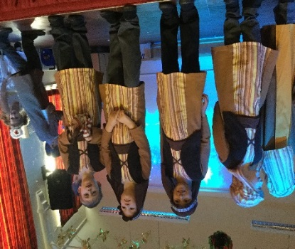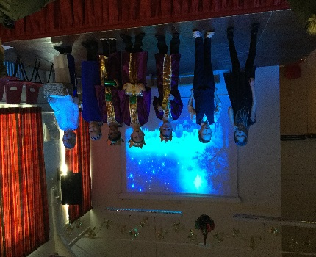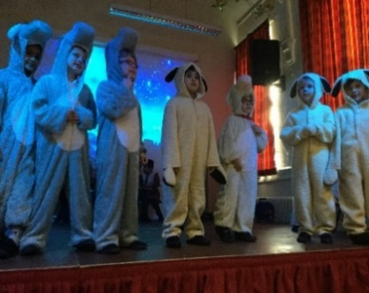

Shobnall PFA Christmas Fair
Last Friday witnessed our first Christmas Fair at school in 12 years! I have to say that the whole event was a huge success and I would like to thank all who attended. The turnout was amazing and I was so proud to see the school bursting with children and their families, aiming to support the school whilst having fun. As you can imagine, the event itself takes a lot of planning and organising and a HUGE THANK YOU goes to our fabulous PFA. The ladies spent the whole day getting the school ready to welcome everyone in and of course preparing Santa’s Grotto – didn’t it look incredible?!?! The grand total of money raising was £1300 and this will be going towards a complete refurbishment of the KS2 library. It is so good to see so many supporting the enthusiasm and dedication of the PFA and they would like to take the opportunity to mention a few more forth-coming events in the Spring term, including another disco and also our Easter Bingo. Dates will be released shortly after the holidays for these events as well as an adult quiz night. You may be interested to know that the staff are already piecing together a couple of teams so please watch this space for dates and really show the staff who’s boss!
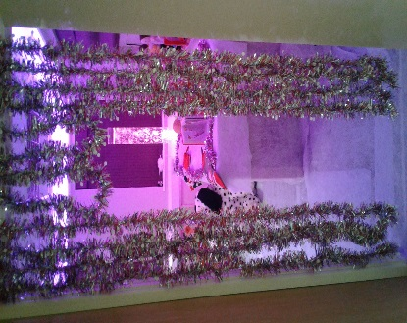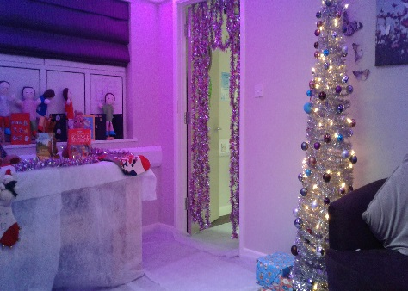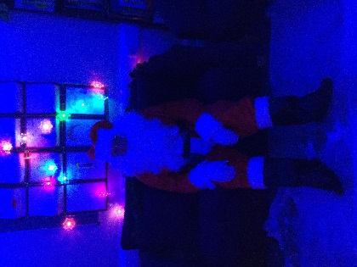
Years 4, 5 & 6 Brewhouse Performance
What a night! For those of you who managed to purchase a ticket for either the matinee show or the evening, you definitely witnessed a great show. We were so proud of all of the children, their conduct, attitude and behaviour was exceptional for what was a very long day. The singing and acting was amazing and it was a real treat to actually watch the whole show during the evening. The evening show was even filled with some fascinating dance moves by many staff although I think that they’d better stick to their day job! Thank you to you all who came along and supported, it was a fabulous show made great by two incredible audiences!

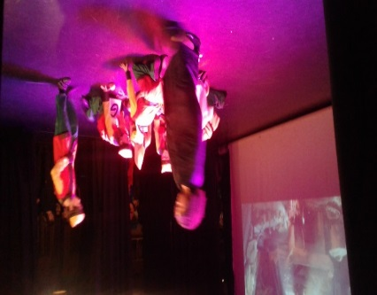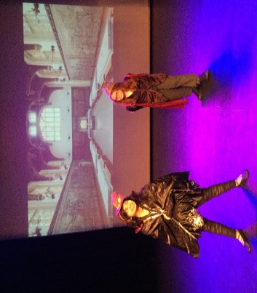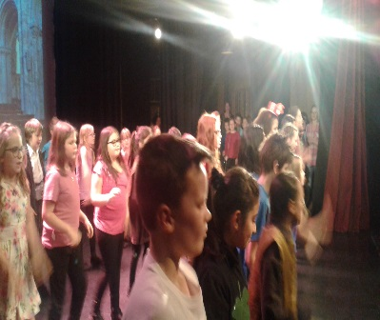

East Staffs Netball Tournament
I have to say that the children who represented the school on Thursday night at Meadowside were an absolute treat and they played so well. I say this because the final outcome was a rather surprising one and the children did not even bat an eyelid when it came to discovering that 2 wins and a draw were not enough to take us through as runners up! After winning 4 – 0, we then drew 1 – 1 before beating Abbotsholme 3 – 0 in our final game. Unfortunately, this wasn’t enough based on rules set and we came home, still unbeaten this season, playing 7 games, winning 6 and drawing 1. Hopefully in March, when the Dove Valley competition recommences, we will be strong enough to win a medal or two. Well done to Paige B, Demi R, Ethan W, Millie R, Liam C, Ava R and a special well done to Jayden M who was drafted in at the last moment, after never actually playing before – a real star. Huge thanks as always to the parents who helped transport and support and of course Sarah Barker whose enthusiasm and energy on the touch line always motivates the children – thank you!
EYFS Nativity Performance
It was a real treat having the opportunity of watching our Early Years perform a very traditional Nativity play. I was absolutely amazed at how so many remembered their lines and how all of the nursery children sat silently but also knew when to stand up and sing. This is even more impressive when you think that most of these wonderful children are still only 3 or 4! It was lovely to welcome so many parents and other family members in to the school and the pride on the faces of all was very obvious, of course it was the first school play that some of the parents have ever experienced! Well done to all of the Early Years staff who compiled such a performance and ensured that all of the children knew the words to the songs and listened so well. A superb effort by all.
Last Week of Term Arrangements
We have a busy final week coming up next week and I would like to take this opportunity of reminding you all about the arrangements. Monday is our Christingle assembly in St. Aidan’s church and if children would like to make one and bring one along, we would love to light it and place it on the alter at the front of the church. Wednesday is our whole school trip to Derby to see Alice in Wonderland, where we will be returning to school around 5pm and we will be dismissing the children, after returning into school from the normal exits. Please await a text on the day for a more accurate time of return. Thursday is the children’s Christmas dinner day where children can either wear Christmas jumpers or if not, clothes of their own choice and this will be without a charge for the non-school uniform. As you are no doubt aware, Friday 16th will be our final day of the term and school will close at 3.30 to pupils until Wednesday 4th January.
Choir Visit to Local Nursing Homes
At this time of year, we can all get a little lost in terms of our own plans and arrangements for the Christmas period but we were delighted to offer both Charlotte James and Amber House Nursing homes the opportunity of listening to our choir. Today, a number of children were selected to visit the nursing homes to sing to the residents and they really were greeted with open arms. It is wonderful to see the faces of the residents light up when our children go in and sing some of the songs that Mr Mansfield has been working on throughout the term. A huge thanks goes to Mr Mansfield but also to Mr Marshment for kindly donating the Burton Venture Trust minibus, free of charge, to enable us to support such a worthwhile cause. Well done to all our choir who sang.

Year 5 – Trip to Nottingham’s Galleries of Justice
To support the learning of Crime and Punishment through the ages, our Year 5 class had a fascinating trip to Nottingham today to learn all about different forms of punishment and the delights of such over the years. The children were given a tour of the museum and also learnt more about the workings of a court room and the judicial system. The trip also included a fascinating tour of prison cells, dungeons and sandstone caves.
Year 3 and 4 Swimming Gala – Uttoxeter
Year 3 and 4 took part in another Swimming tournament this week at the Uttoxeter Leisure centre. The children did tremendously well, competing against 13 other schools, including several private schools and managed to win several events, including Front crawl and Back crawl races and came 6th overall. The child that took part were Amber.W., Isla.J., Daisy.T. Francesca.E, Robey.W., Ceron.G. and Archie.S.
Head Teacher Assembly Awards
Nursery | Whole Class Award for the children’s superb performance in their Nativity “Mary’s Knitting” – Well done everyone – Excellent!!!
Reception
Year 1 | Alys J | Stephen C
Year 2 | Elsie W | Archie W
Year 3 | Ethan H | Abdullah Y
Year 4 | Aleeza S | Jack P
Year 5 | Brooke H | Charley W
Year 6 | Harvey D | Olivia G

Lunchtime Star Awards
Reception | Eva W – Brave, lovely manners
Year 1 | Millie D – for always being happy and friendly
Year 2 | Archie W – Super behaviour and manners
Year 3 | Lewis T – Excellent behaviour
Year 4 | Aleena H – Excellent behaviour
Year 5 | Ashton M – Excellent behaviour
Year 6 | Laila R – Lovely manners and friendly

Autumn Term 2016 – Dates for your diary
Event | Date and Time
Last Choir Practice | Friday 9th December 2016
Christingle Service St Aidan’s Children Only | Monday 12th December 2016
Influenza Vaccinations for Years 1, 2 and 3 | Medical Room Tuesday 13th December 2016
Pantomime Theme Lunch Day | Wednesday 14th December 2016
Visit to Derby Playhouse for Pantomime | Wednesday 14th December 2016
Christmas Lunch for all Pupils  “Christmas Jumper” non-uniform day | Thursday 15th December 2016
Theme Lunch Day “Party Bag” | Friday 16th December 2016
School Closes for Christmas Holiday | Friday 16th December 2016 at 3.30 pm
School re-opens for the Spring Term | Wednesday 4th January 2017
Year 5 Class Assembly | Wednesday 11th January 2017 at 9.00am
PFA Meeting | Wednesday 18th January 3.30pm
Young Voices concert – NEC, Birmingham | Monday 30th January – leaving around 12.15pm – 9.00pm

