SHOBNALL PRIMARY SCHOOL – 1ST APRIL 2015 – 31ST MARCH 2016

Sports Premium Report
Shobnall Primary School appreciates the contribution of PE to the health and well-being of its children. We also acknowledge that a broad, balanced, high quality curriculum and extra-curricular activities have a positive impact on concentration, attitude and achievement.

The whole team is committed to ensuring that all pupils receive a minimum of 2 hours of PE per week, delivered by well-trained and enthusiastic teachers. The Sport Premium funding is allowing us to develop a sustainable improvement in teacher confidence and a new curriculum based on developing children’s physical literacy skills. Regular staff training opportunities are provided for teachers and teaching assistants (TAs) to keep them abreast of new initiatives.

We intend to run a Sports Week; including competitive events for KS1 and KS2, this is addition to our annual Sports Day which includes running events. Teachers and TAs provide a wide range of after school sports clubs, both for team and individual sports.

What is the Sports Premium?
The government is providing funding in excess of £150 million per annum for the academic years 2015/16 to provide new and substantial primary school sport funding. The funding is being jointly provided by the Departments for Education, Health and Culture, Media and Sport, and will see money going directly to primary schools to spend on improving the quality of sport and PE for all their children. Each school will receive around £8,000. The money can only be spent on sport and PE provision in schools.

Monitoring and Evaluation
- This report will be updated at the end of each academic year to identify the success of the above initiatives and the impact that they have had.
- Delivery will be monitored by the PE Leader in the first instance. This will be overseen and managed at senior level by the Headteacher and Deputy Head.
- Monitor the take-up of extra-curricular activities.
- Monitoring will include observations of teaching, drop-ins to clubs run by school staff, volunteers and outside agencies to ensure that provision is of high quality.

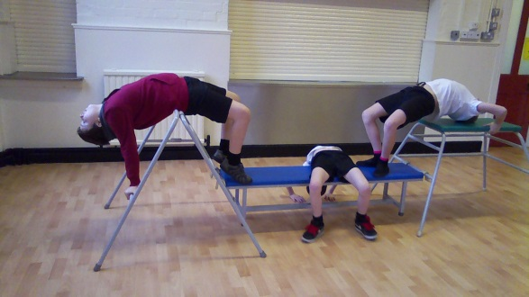
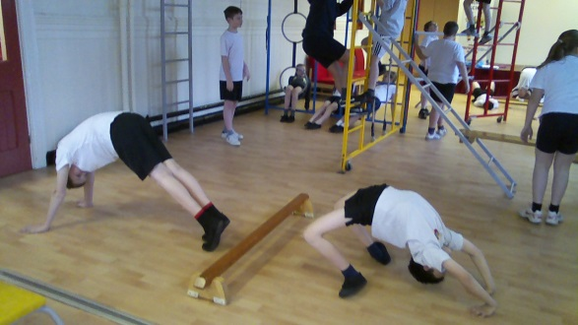
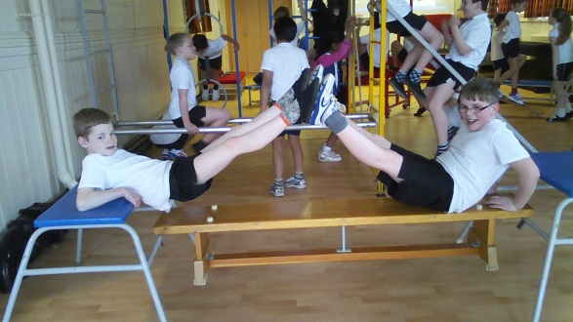
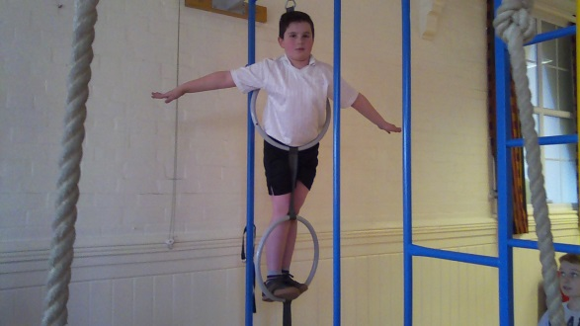
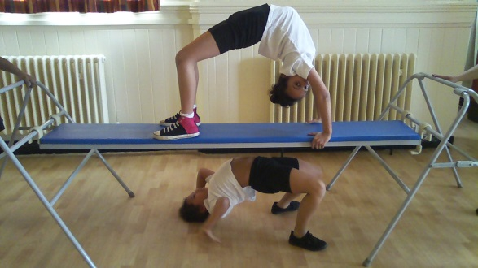
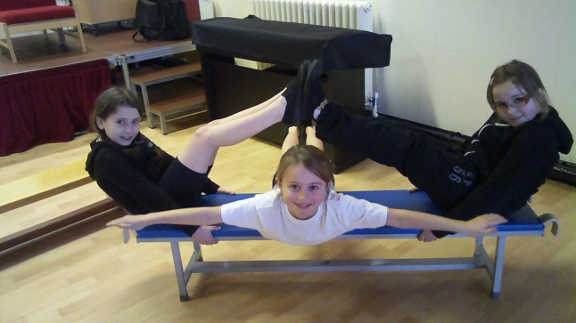
IMPACTS OF SPORT PREMIUM SPENDING 2014 – 2015

SCHOOL BUDGET RECEIVED £8,550 FOR 1ST APRIL 2014 TO 31ST MARCH 2015

COMPANY | AREA OF FOCUS | IMPACT 1st APRIL 2014 – 31ST MARCH 2015
DfE | PE & Sport Grant Income
Sue Welch  PE Instructor | Increase the Range of Provisional and Alternative Sporting Provision  Hockey After School Club (24 wks x 1hr)  Forest Schools (6 weeks) (2.5 hrs) each class developing an outdoor forest school activity. | As a result of continuing to offer an extensive range of sporting activities both within and outside of the school day, pupils are being provided with the confidence to try out new activities.  As the curriculum has been adapted and updated to meet the requirements of the new curriculum as well as previous Ofsted targets, all children are displaying positive relationships and full integration into the Forest schools initiative as well as extended outdoor learning opportunities.
ESBC | Participation rates in such activities as games, dance, gymnastics, swimming and athletics curriculum  Hire of Facilities at Shobnall Leisure Complex for Tournaments and Training | Children have had access to high quality facilities at the local leisure centre throughout the majority of the school year and as a result of such access, the school celebrated becoming Dove Valley Hockey champions for this academic year.  In addition to the above, pupils have continued to have the opportunity of accessing a wider range of sports throughout the year in a range of different and diverse range of environments, from the school setting, to the local leisure centres as well as a farm setting for Forest School teaching.
Sue Welch  PE Instructor | Working with NQT (support in PE lessons & coaching) 8 sessions / 1.5 days | As a result of training and support offered by the PE teacher, all three NQTs have been motivated in their development of teaching high quality PE lessons. All staff now are confident to deliver high quality PE lessons as well as extra - curricular sporting clubs.
Sue Welch  PE Instructor | Partnership – Work on P.E. with Other Partner  INSET Staff Training (1 day) | In line with the vision of the school through its extensive school improvement plan, the staff were provided with a high standard of training which has led to an improved level of confidence in the delivery of the subject as well as developing lesson structure which is now improving the enthusiasm and motivation of pupils involved.

COMPANY | AREA OF FOCUS | IMPACT 1st APRIL 2014 – 31ST MARCH 2015
DfE | PE & Sport Grant Income
Dove Valley | Annual subscription 2014/15 | The Dove Valley membership is invaluable as a school in terms of promoting competitive and representative sport for all pupils aged year4 upwards. This provision has aided the wider community links with the school as well as fostering positive relationships within the sporting context with the 12 other schools included in the association. The children play competitive fixtures throughout the year in many sports including: Football, netball, rugby, hockey, cricket, rounders and athletics. We are currently the Dove Valley champions of netball and hockey.
Active Learning Sports, J Attwood | The enhancement and extension of our curriculum provision  EYFS & KS1 Provision of Physical Education  Lunchtime Supervisor training | PE has developed into a more informal setting through the training and development of young sports leaders in our Active Playground approach. Pupils are offered a range of activities to participate in throughout the year at lunch times and are consulted by the children as to the sort of games and skills they would like to participate in.  As a result, pupils are therefore encouraged to develop their leadership and coaching skills with younger pupils.
Bishop Sports & Leisure | Introducing an in-school physical activity programme  Soft Balls, Touch Hand Balls, Bullnose Javelins | Pupils continue to benefit from improved resources in school and the resources are utilised by both staff (in PE lessons) and children (in active playground). As a result, the teaching and learning is tailored far more to the individual needs of the children because they are matched to not only the lesson objectives but also the excellent resources now available.
Hope (Findel) | Introducing an in-school physical activity programme  Super-Safe Footballs Hope Education | Pupils continue to benefit from improved resources in school and the resources are utilised by both staff (in PE lessons) and children (in active playground). As a result, the teaching and learning is tailored far more to the individual needs of the children because they are matched to not only the lesson objectives but also the excellent resources now available.
Bishop Sports & Leisure | Introducing an in-school physical activity programme  Badminton Sets, Dodge Balls and Rackets | Pupils continue to benefit from improved resources in school and the resources are utilised by both staff (in PE lessons) and children (in active playground). As a result, the teaching and learning is tailored far more to the individual needs of the children because they are matched to not only the lesson objectives but also the excellent resources now available.

COMPANY | AREA OF FOCUS | IMPACT 1st APRIL 2014 – 31ST MARCH 2015
DfE | PE & Sport Grant Income
Hope (Findel) | Introducing an in-school physical activity programme  Football Goal Posts | The new goal posts have been purchased in both KS1 and KS2 playgrounds. As a result, the children are now able to demonstrate a far better attitude towards other pupils not playing and thus resulting in few incidents on the playgrounds. The behaviour of children has improved as a result of new resources as these were purchased through an initiative instigated by the school council.
Hope (Findel) | Introducing an in-school physical activity programme  Extra Football Goal Posts KS2 Playground | The new goal posts have been purchased in both KS1 and KS2 playgrounds. As a result, the children are now able to demonstrate a far better attitude towards other pupils not playing and thus resulting in few incidents on the playgrounds. The behaviour of children has improved as a result of new resources as these were purchased through an initiative instigated by the school council.
Youth Sport Direct Limited | Multi-skills KS1, KS2, Festival Resource & Multi skills resource pack.  Active play resource cards | In order to ensure high quality provision through the by offering a broad range of sporting activities, the school purchased additional teaching resources to ensure a diverse PE curriculum which provides the children with the confidence to try new activities as well as enhancing the pupils’ existing skills.
Kingswood | Links with other subjects that contribute to pupils’ overall achievement and their greater Spiritual, Moral, Social and Cultural skills (SMSC)  Residential week | The school residential trip to Kingswood in Staffordshire ensures that pupils’ in the Year 6 class have the opportunity of enhancing a widening range of skills in a diverse range of environments.  As a result of our attendance at this centre, children develop excellent relationships with other pupils and staff.

COMPANY | AREA OF FOCUS | IMPACT 1st APRIL 2014 – 31ST MARCH 2015
DfE | PE & Sport Grant Income
Entrust | Quality and qualifications of staff providing the activity  Games Course, Mrs S Welch | Through CPD opportunities provided for both the PE co-ordinator and staff who are primarily responsible for delivering PE, the staff as a whole are able to create a diverse and broad PE curriculum to ensure the development of pupils’ positive attitudes to learning.  The school policy ensures that active lifestyles are being promoted and the school proudly boasts its Healthy School status.  Self- assessment opportunities are built into lessons delivered by Sue Welch and this enables children to celebrate their achievements and evaluate and improve their performance in the future.  The school reporting systems enable Sue Welch and all teachers of PE to comment to parents on the quality of their child’s performance and their contribution to PE lessons.
Sue Welch  PE Instructor | AFPE Level 5 Registration payment 1 of 3
Sue Welch  PE Instructor | AFPE Level 5 Registration payment 2 of 3
Sue Welch  PE Instructor | AFPE Level 5 Registration payment 3 of 3
Entrust / ESBC | Swimming lessons additional instructor for year class with 37 pupils charged at £37.20 per session x 10 sessions | Through the employment of a skilled and highly competent member of staff for swimming sessions, the quality of provision to smaller groups of pupils is excellent and as a result, significant numbers of pupils are achieving awards in years 4 and 5 each year.

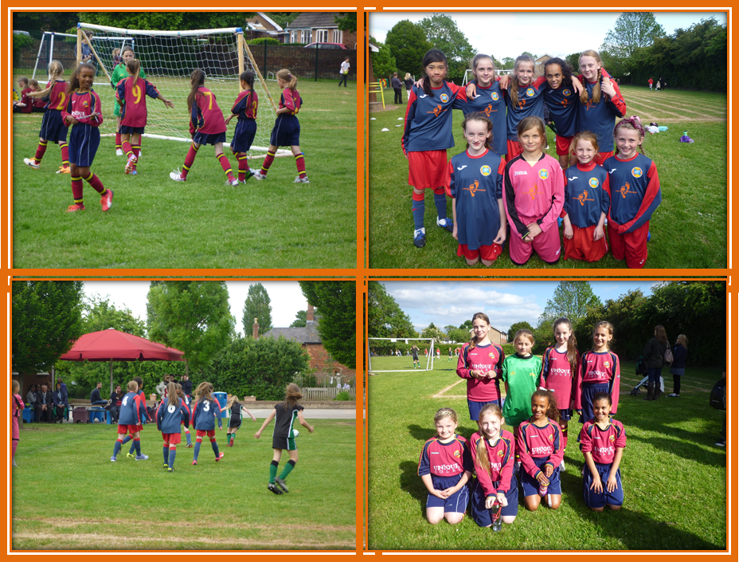

IMPACT OF SPORTS FUNDING ON PUPIL PARTICIPATION

CLUB | TERMS | 2014-2015 PUPILS
Netball Y5/6 | Autumn and Spring
Football Y5/6 | Autumn and Spring
Tag Rugby Y5/6 | Autumn
Hockey Y3/4/5/6 | Autumn, Spring and Summer
Badminton Y3/4 | Summer
Rounders Y5/6 | Summer
Cricket T4/5/6 | Summer
Multi-Skills Y1/2 | Autumn
Dance Club Y3/4 | Spring
Playground Games Y1/2 | Autumn and Spring

COMPETITIONS ATTENDED 2014 TO 2015
TOURNAMENT | RESULT IF APPLICABLE
Dove Valley Netball League | Winners
Dove Valley Netball Cup | Runners Up
Dove Valley Football Leage | Runners Up
Dove Valley Football Cup
Dove Valley Hockey | Winners
Dove Valley Rounders
Dove Valley Athletics | No winning school – general participation
Dove Valley Cricket | Group winners, semi-finalists
East Staffs Netball District | Runners Up
East Staffs Cricket | Group winners, semi-finalists
East Staffs Girls Cricket | Third Place
East Staffs Hockey | Semi Finalists

Shobnall Primary Targets for Sports Premium 2015 – 2016

TARGETS FOR SPORTS PREMIUM – 2015-2016
- Engaging the least active children in a “Change for Life” club.
- The engagement of all pupils in regular physical activity.
- The profile of PE and sport in general will be raised across the school as a tool for whole school improvement.
- To achieve the School Games Kite Mark – GOLD award.
- To undertake pupil and adult consultation regarding the activities and the provision on offer in PE which includes both curricular and non - curricular provision.
- To devise a Hall of Fame Display which reflects the rich, varied and inclusive school sport on offer which will act as an extension to the existing curriculum.
- In line with the new curriculum, ensure it is diverse and provides pupils with the confidence to try new activities as well as enhancing their existing ski8lls in a diverse range of environments.
- To incorporate opportunities for the development of young leaders in coaching and organising structured but formal and informal skills.
- To ensure the continuation of provision in the Dove Valley Sports Association empowering pupils with opportunities to compete in a range of competitive experiences within and beyond school.
- To offer children the chance to experience both winning and losing in fun, competitive situations and opportunities to learn how to deal with success and disappointment.
- To ensure that PE within the school makes an excellent contribution to pupils’ spiritual, moral, social and cultural development.
- To create opportunities for the implementation of a successful intra-school completion programme.

ACTION PLAN FOR 2015-16
Our Sport Premium Funding for 2015-16 is: £8,550 Actual Costings £11,180 Overspend £2630
Item/project | Cost | Objectives | Outcome
Professional development
Dove Valley Schools Sports Partnership | £250 | To participate in local competitions and events in East Staffordshire. | All pupils are able to access school sports events. PE and sport are used to foster positive relationships with other schools.
The PE co-ordinator to attend CPD opportunities to enable him to develop in the role of PE co-ordinator. | £250 | To ensure that the PE co-ordinator will feel confident in middle management and be able to raise the profile of the subject whilst playing a role in the monitoring of the subject. | A recognition and understanding of what high quality PE and sports provision looks like and how to develop and improve the subject across the whole school.
Participation & Access
Sue Welch PE Instructor | £600  Club (24 wks x 1hr @25 per hour) | To provide experienced and quality first teaching in the delivery of an after school hockey club. | The school continues to provide an extensive curriculum to ensure breadth and depth
Kingswood Residential Week. | Transport  £600  Additional TA Supervision  £400 | To ensure that every child has access to opportunities outside of the classroom and develop both independent and social skills. | All children in Year 6 are able to access a broad offer of school physical activities which includes an extensive range of activities on offer.

Participation & Access
Additional After School Sporting Oppportunities  James Attwood | 39 wks x 1hr @25 per hour) 5 times  £4875 | To ensure that children have access to professional facilities to enable them to access and enjoy non competitive activities
Playground Leader training | £150 | To train Y6 sports leaders – delivered by James Attwood | To improve structure of lunchtime play and activities.
ESBC – Hire of facilities at Shobnall Leisure Complex. | £125 | To ensure that children have access to professional facilities to enable them to compete competitively in local competition. | All children will have access to a broad curriculum and facilities outside of the school’s curriculum.
School Swimming Service – additional instructors for Y4 and Y5 pupils. | £380 | To provide an additional teacher to reduce ratios of children to adults in weekly swimming sessions. | All pupils in years 4 and 5 have access to competent and high quality swimming teaching and all pupils involved are encouraged to participate top the best of their abilities.
Improve the access and resources for effective and high quality outdoor provision and teaching. | See school expenditure for individual costs  £500 | To resource the new outdoor learning area with equipment such as orienteering equipment. | Pupils will be provided with access to improved outdoor resources to enhance the provision of PE in a diverse range of environments.

Participation & Access
To provide netball court markings on the Key Stage 2 playground | £100 | To ensure that the playground markings are completed at the earliest opportunity to extend opportunities both within and outside of the school’s curriculum. | Staff in charge of delivering netball sessions will have greater opportunities of playing competitive games and therefore extending the opportunities to more children to attend netball club.
Devise a wall of fame display and to be kept updated fortnightly depending on fixtures of school at sporting events. | £250 | To identify a board which can be entitled “Wall of Fame” and will include a list of fixtures, photographs and achievements of all school pupils both in and out of school | A recognition and impact of the high quality PE and school sport which pupils and parents understand and will have contributed to.  Used as a tool to motivate other pupils and illustrate how PE and sport can be used to engage the school community and foster positive relationships with other schools.
Create a Change for Life Club to encourage less active pupils to participate in sporting activity. | Change 4 Life Club (24 wks x 1hr)  £480 | To enable and empower a teaching assistant to plan and deliver a 6 week termly program which is designed to promote a healthy lifestyle and promote fitness opportunities. | Positive attitudes towards healthy and active lifestyles are encouraged among pupils and is also extended to parents and carers.  Increased physical activity levels amongst the least active young students in schools.

Improving activity & fitness
Create a Change for Life Club to encourage less active pupils to participate in sporting activity. | Change 4 Life Club (24 wks x 1hr)  £480 | To enable and empower a teaching assistant to plan and deliver a 6 week termly program which is designed to promote a healthy lifestyle and promote fitness opportunities. | Positive attitudes towards healthy and active lifestyles are encouraged among pupils and is also extended to parents and carers.  Increased physical activity levels amongst the least active young students in schools.
Plan and implement an intra - school Sports Event. | Supply costs and extra TA cover for supervision for additional teams  £1000 | To provide all children in having the opportunity of playing and competing in intra school competition encompassing a wide range of sporting activities. | All pupils are able to access a broad range of school sports activities and an extensive range of sports will be available.
Planned opportunities are built into the school monitoring cycle to obtain pupil and stakeholder feedback as to the current sporting provision and ways in which we could improve it. | 3 mornings x130  = £390 | Children and stakeholders to be able to comment on the current provision and as a result will ensure broad coverage is on offer in terms of the school curriculum and extra - curricular timetable. | Strategies will be place to ensure that pupils and adults are consulted about the range of activities offered.

Celebrating achievement
School to actively seek and obtain the Sports Games Kite Mark Gold award. | £350 | To ensure the PE co-ordinator will complete the Kite Mark documents with the aim of achieving the highest possible award. | As a result, this will enable the school to both document its achievements whilst also share the impact of all initiatives identified in this plan.
Total Costings for 2015-2016 Action Plan
Actual Costings £11,180 Overspend £2630
Our Sport Premium Funding for 2015-16 is: £8,550

