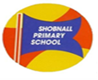
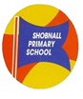
333399333
Shobnall Primary School
Newsletter

Telephone: 01283 239100 Facsimile: 01283 239105 e-mail: headteacher@shobnall.staffs.sch.uk

Dear Parents and Carers, 6.1.2017

A very Happy New Year to you all! A warm welcome back to the new term, it seems strange saying that this is the Spring term when the weather outside is far from Spring-like! Anyway, I hope that you had a restful and peaceful Christmas break and are settled back in to the routines of everyday normality, the children certainly are and it seems like we have never been away!
It has been an incredibly busy and eventful three days back as the teachers have been focusing on delivering a creative PSHE curriculum. Personal, Social and Health education is an extremely important element of learning for children as without these fundamental skills, pupils struggle with all aspects of education and life skills. Therefore, the teachers have delivered a range of different activities throughout the three days and some of these have been documented on Twitter so do please have a look. Here is an overview of the three days in each class:

YEAR 1
Year 1 have been very busy learning about how we are all different. We thought about how we are special as individuals and the diversity of different cultures around us. We have compared different cultures, such as the Chinese, Indian and Muslim culture to the English culture. We learnt about many differences for example, clothes, food, appearance, music, languages, art and celebrations. We have been very fortunate to have some visitors join the class to discuss the Chinese New Year and draw henna patterns on the children’s hands. It has been a very enjoyable and knowledgeable start to the spring term!
YEAR 2 PSHCE

This week Year 2 have been lucky enough to have a visit from staff at Burton Hospital. We were taught by several nurses who showed us how to use lots of different equipment. Children had the opportunity to use a stethoscope, heart monitor, blood pressure monitor and much more! Year 2 have been phlebotomists, brain surgeons, heart surgeons, doctors, hygienists and enthusiasts! A big thank you to Burton Hospital.

YEAR 3 PSHCE JANUARY 2017

Year 3 have been learning all about the role of money in everyday life. A visitor came into class bright and early on Wednesday morning to teach us all about receiving money and the importance of identifying the difference between wanting and needing something. This then led us into our learning all about Water Aid and the great work they do across the world. We looked at how those less fortunate than us need help to receive clean, healthy water for drinking and hygiene. To demonstrate this, we did the 'Pipeline Challenge' to see how hard it is to get water that isn't from a tap. We also wrote diary entries from the eyes of children that don't have access to water like we do.

YEAR 4 PSHCE WEEK

The focus for this week’s learning for Year 4 has been ‘Differences’. On Wednesday, the children listened to and researched a variety of songs that aimed to highlight differences in how people are treated and differences in people’s views. The songs included Aretha Franklin – Respect, Sam Cooke – A change is Gonna Come, Edwin Starr – War and John Lennon – Imagine. The class discussed what the message was within each song and why it was written. On Thursday, the class focused on stereotypes, thinking in particular about; why they exist and how we can change them. Throughout the day, the children also experienced what it was like to either be privileged or deprived. This was done through treats such as iPad time or extra break time being given to one half of the class, whilst the other half did not receive these. Over the course of the day everyone experienced being both privileged and deprived. Friday’s activities centred about debate and discussion. In groups, the children spoke about the ways in which they are similar and different from each other and then attempted to answer difficult questions such as; is it worse to fail at something or never attempt it in the first place and is it more important to be liked or respected?

YEAR 5 PSHCE

We have held a PSHE week, focussing on Homelessness. We began the topic by researching what is actually meant by the term, whose fault it is, the causes and the resulting effect from this.

On Thursday, we were spoilt with two special visitors, Reverend Pete Orton from the YMCA and our very own Mrs Cox. Reverend Pete gave an in-depth presentation on the topic, including the statistics - both myself and the class were shocked to hear that over 120,000 young people were left homeless last year. The discussion helped provide the class with a first-hand account of not only the causes and effects associated with homelessness, but also what we can do to help those in need. A very interesting and inspirational presentation. During the afternoon, Mrs Cox discussed her experience of dealing with those that are homeless and shared stories to help their understanding of the topic. Both visitors were amazed at the class’ contributions and the children should be very proud of this.
Finally, the class have read ‘The Good Samaritan’ and created some fabulous freeze-frames to represent the scenes within this. The moral of this tale was summarised by the class as ‘If you see those in need, push aside your differences and help them out - be a Good Samaritan.’ The children have adapted this tale into their own modern version, which shall be performed to the school and parents during their class assembly next Wednesday.
Well done Year 5 for showing a really good level of engagement throughout the topic and with our special guests, you did the school and yourselves proud!
YEAR 6 PSHCE

In Year 6, as well as creating our own New Year’s resolutions, we have been exploring Black History Week and why it is celebrated every year! We have learnt about the accomplishments of famous black men and women in history and how their achievements have impacted on combatting racism today and gaining greater equality for all. We have had some lively discussions around these issues!

Healthy Snacks
It has come to the attention of the school that a number of children have begun to stretch the boundaries of our Healthy School Policy. Please can I remind all of our parents and carers that as a school, we are proud of being classed as a “Healthy School” and we would like to retain this title. However, in order to do so, the children are reminded that snacks brought in to the school for break times should be either a piece of fresh fruit or dried fruit only. There is no exceptions to this as other snacks such as fruit winders and cereal bars contain significant amounts of sugars and salts which are therefore not a healthy snack. Please can you ensure that children are provided with fruit or dried fruit if you so wish for consumption at break time and do not eat the other contents of their lunch box until lunch time itself.
Thanking you in advance for your co-operation.

Head Teacher Assembly Awards
Reception | Ashton M | Zoya H
Year 1 | Fezaan A | Eva W
Year 2 | Elsie W | Zoe C
Year 3 | Scarlett S | Sayaan UH
Year 4 | Isabelle W | Ben D
Year 5 | Spencer W | Kian J
Year 6 | Charli G | Safa H

Lunchtime Awards

Reception | Ibraheem M. | 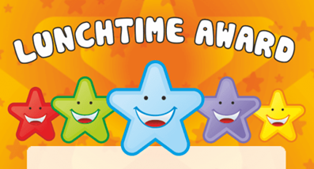
Year 1 | Alfie L.
Year 2 | Sophie T.
Year 3 | Archie S.
Year 4 | Zakariyah H.
Year 5 | .Valerija K.
Year 6 | Sana H.
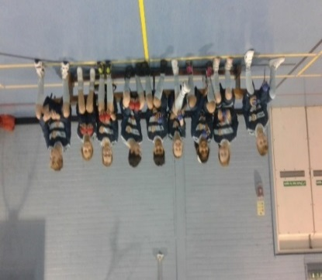

BOCCIA TOURNAMENT 5th JANUARY 2017
Wow - Superstars!
The Boccia team represented Shobnall at the Robert Sutton tournament on Thursday 5th January 2017 and made it through to the semi-finals – Well done to all the children who took part.

Diary Dates/Events | Date and Time
Year 5 Class Assembly | Wednesday 11th January 2017 at 9.00am
Swimming Lessons re-start Meadowside Leisure Centre for Year 5 | Tuesday 17th January 2017
PFA Meeting | Wednesday 18th January 2017 3.30pm
Young Voices Concert – NEC, Birmingham | Monday 30th January – leaving around 12.15 pm – 9.00 pm
World Book Day | Thursday 2nd March 2017

