SHOBNALL PRIMARY SCHOOL
SPORTS PREMIUM IMPLEMENTATION:-
School Budget received £8,550 for 1ST April 2013 to 31st March 2014

AUDIT AND CONSULTATION – 2013 - 2014
- Consultation took place with Parents and Governors to ensure that the Sports Premium funding delivers high quality physical education in school sport.

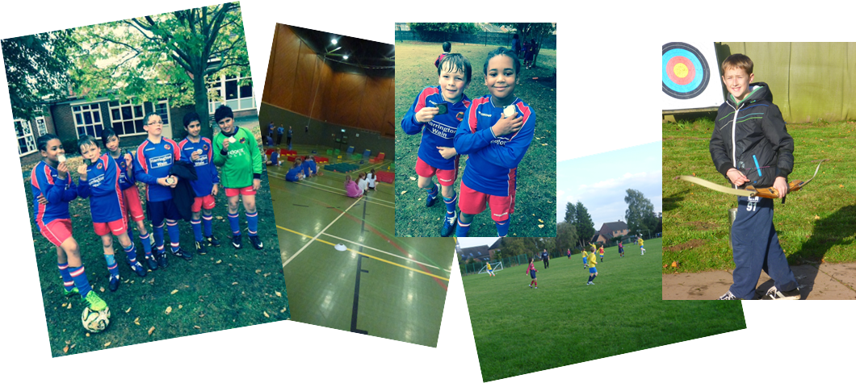

TARGETS FOR SPORTS PREMIUM – 2013-2014
- Targeted strategic support which improves the outcomes for all children and builds staff confidence in the teaching and learning of P.E.
- To ensure the skills of sportsmanship are embedded within the school curriculum.
- To improve participation amongst students in intra and inter school sport.
- To provide resources to ensure that PE provision is enriched and extended.

COMPANY | AREA OF FOCUS | DATE | YEAR GROUP | TOTAL COST £ | BALANCE REMAINING
DfE | PE & Sport Grant Income | Oct 2013 | Ages 5 - 11 | 8,550.00 | 8,550.00
SCC QLS | Staff Professional Learning  National Sports PE Conference | 13th June 2013 | Kingston Centre | 195.00 | 8,355.00
Amazon | Staff Professional Learning  Safe Practice in PE and Sport, by P Whitlam. (PE Health & Safety Book) | June 2013 | Whole School | 40.00 | 8,315.00
Wicksteed Leisure | Participation in Sports – Safety Checks  Outdoor Play equipment annual safety check | Sep 2013 | Whole School | 42.00 | 8,273.00
Sue Welch  PE Instructor | Increase the Range of Provisional and Alternative Sporting Provision  Hockey After School Club (38wks x 1hr) | April 13 - March 14 | KS2 | 728.00 | 7,545.00
Sue Welch  PE Instructor | Partnership – Work on P.E. with Other Partner  INSET Staff Training (1.5 days) | January 2014 | All Staff | 187.00 | 7,358.00
Sue Welch  PE Instructor | Working with NQT (support in PE lessons & coaching) | Autumn term 2013 | Year 3 teacher, who could support other years in sports tournaments | 115.00 | 7,243.00
Dove Valley | Annual subscription 2013/14 | Autumn term | KS2 | 30.00 | 7,213.00
Hope (Findel) | Participation rates in such activities as games, dance, gymnastics, swimming and athletics curriculum – extend opportunities for younger pupils  Football Goal Posts | December 2013 | KS2 | 325.40  325.40 | 6,887.60  6,562.20

SHOBNALL PRIMARY SCHOOL
SPORTS PREMIUM IMPLEMENTATION (Cont’d):-
School Budget received £8,550 for 1ST April 2013 to 31st March 2014
COMPANY | AREA OF FOCUS | DATE | YEAR GROUP | TOTAL COST £ | BALANCE REMAINING
Kingswood | Links with other subjects that contribute to pupils’ overall achievement and their greater Spiritual, Moral, Social and Cultural skills (SMSC)  Residential week | 4-8th Nov 2013 | Year 6  (14no. pupils) | 1750.00 | 4,812.20
Ruff Tuff Stuff Limited | The range of provisional and alternative sporting activities  Balance Bikes x10 | November 2013 | KS1 | 900.00 | 3,912.20
Active Learning Sports, J Attwood | The enhancement and extension of our curriculum provision  KS1 Bike course & Lunchtime Supervisor training | Spring Term 2014 | KS1 & KS2 | 880.00 | 3,032.20
Entrust | Quality and qualifications of staff providing the activity  Games Course, Mrs S Welch | March 2014 |  | 165.00 | 2,870.20
 | Introducing an in-school physical activity programme  Foam Dodgeballs x12 | March 2014 |  | 73.64 | 2,796.56
Sue Welch  PE Instructor | Providing high quality professional learning for adults supporting learning (ASL’s) to run sports teams, after school clubs and intra-school opportunities | 7 Nov 13 2hrs  10, 16, 24 & 30 Jan 14 10hrs total  7, 28 Feb 14 5hrs total |  | 271.32 | 2,525.24

SHOBNALL PRIMARY SCHOOL

SPORTS PREMIUM IMPLEMENTATION (Cont’d):-
School Budget received £8,550 for 1ST April 2013 to 31st March 2014
COMPANY | AREA OF FOCUS | DATE | YEAR GROUP | TOTAL COST £ | BALANCE REMAINING
ESBC | Participation rates in such activities as games, dance, gymnastics, swimming and athletics curriculum  Hire of Facilities at Shobnall Leisure Complex for Tournaments and Training | Spring 2 / March 2014 | KS2 | 100.50 | 2,424.74
Entrust / ESBC | Swimming lessons additional instructor for Year 6 class with 37 pupils charged at £37.20 per session x 20 sessions | Autumn 1  Autumn 2  Spring 1  Spring 2 | Year 6 KS2 | 744.00 | 1,680.74

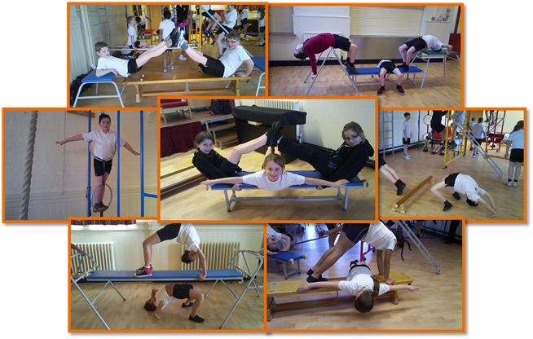

IMPACT – 2013-2014
- As a result of 1:1 support and mentoring for all teaching staff, including all staff Inset, the PE specialist for CPD for staff has improved the staff confidence, skill and competence.
- Pupil participation in inter-school competitions has increased as a result of further development of the football teams to widen opportunities for boys, girls and all year groups. This has also been achieved through the maintenance and development of all current commitments within the Dove Valley League.
- The amount of physical activity at lunchtime has increased through Active Playgrounds as the gross motor skills of targeted pupils has improved, thus raising their self-esteem and attainment. This has also developed leadership opportunities with the children who devised and ran the summer sports day festival for EYFS, KS1 and KS2.
- There is increased participation in sporting activities for pupils eligible for pupil premium as indicated on the After School Activity Analysis. All pupils in school have participated in at least one school club giving them access to a qualified coach.

