
Friday 19^{h} September 2025
Please complete the following:
English | Look carefully at the picture you have stuck in your homework book.  Write about what you can see and what you think might be happening. Use the ideas below to help you. You don’t need to answer every question – choose the ones that help you the most.  Ideas to help you get started:  - What can you see?  - What colours, shapes or details do you notice?  - Where do you think this could be?  - Who or what might be there?  - What could they be doing?  - What do you think happened before the picture?  - What might happen next?  - How does the picture make you feel? Why?  - Can you describe something using interesting adjectives (e.g. big, shiny, bumpy)?  Helpful Starter Sentences:  - I can see…  - There is…  - The … looks…  - This makes me feel…  - I think…  - Next to the… I can see…  - In the background…  - I wonder if…  I cannot wait to see what you write!
Maths
Every week | Spellings  Practise your spellings. These will be uploaded on Spelling shed too. You will have a test on Friday.  Reading  Read at home on at least three separate occasions and record in your reading diary. These must be handed in daily to be signed.  Times Table Rock Stars  If you get a spare 10 minutes, login and challenge yourself on the facts we have already learnt. 2s, squares and 5s.  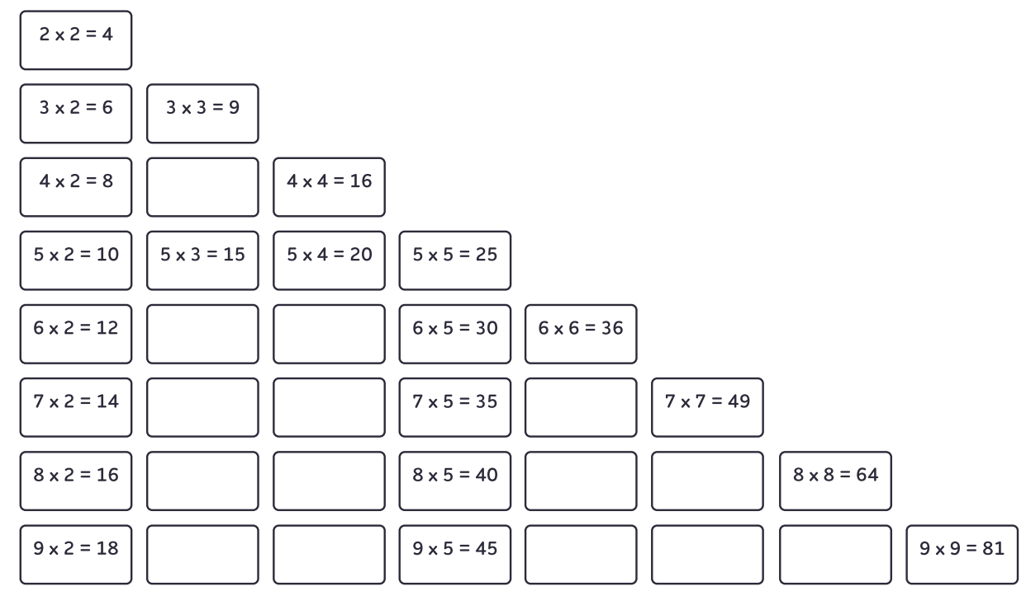

If you need help on how to complete the tasks, please ask! Don’t leave it until Wednesday!
Remember, have a go and try your best!

